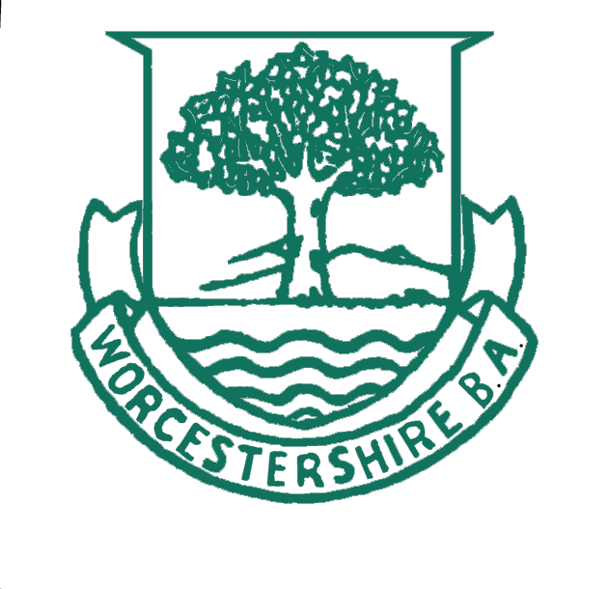
Walker Cup
Season 2025 Ladies County Fixtures

The Walker Cup squad of 15 players has been selected from which the final team will be named.

The squad is:
Broadway – Sue Davies, Viv Hall, Joan Parfitt, Debbie Seward, Amy Walters.
Chester Road – Maddie Burgess, Aqua Griffiths, Izzie White
Pershore – Alison Cartwright, Ali Foote, Julie Howell, Pam Icke, Lesley Wood
St Dunstan’s – Eira Drake, Judy Drewer.

The squad got together on Sunday 4 May for a practice before the Regional Finals, which take place over the weekend of the 17/18 May at Broadway Bowling Club. Bowls England has published the playing schedule for the finals weekend. We play:
- The opening game on the morning of Saturday 17 May against Warwickshire, starting at 9.30am.
- Saturday afternoon at 4.00pm against Gloucestershire.
- The last game on Sunday 18 May, at 4.00pm against Herefordshire.

We are all looking forward to a very competitive weekend of bowling. Please come and support the players.
Alison Cartwright and Julie Howell
Team Manager & Match Secretary

