Today was the beginning of the 2025 campaign for the Francis Burton. It was also the first competitive game for Stuart Munro (Pershore), Jack Pullin was also back in action playing for the county. Was also great to see Macca back playing.
We had a great start to the game at 5 ends we were +28 shots losing on one rink, drawing on one and winning the other 4 rinks. Slim (9 v 1), Millward (9 v 1) and Griffiths (11 v 0) rinks taking an early lead. At 10 ends we were still up +29 shots and winning on all 6 rinks. But over the next 5 ends we seem to take the foot of the gas as Derbyshire had a surge of shots, but we still held onto the lead of +20 shots. Up on 5 rinks and 5 shots down on Slims rink, this changed on the 17th end for slims rink, when he managed to peel a bowl out for 4. This changed the dynamics on that rink as they never looked back. From ends 15 to 18 the team stretched their lead to +31 losing on one rink drawing on two rinks, winning on three. The last 3 ends for the boys saw us go to a +41 shot difference, winning on 5 rinks and the loss on one rink. A fantastic start picking up 20 out of the 22 points available.
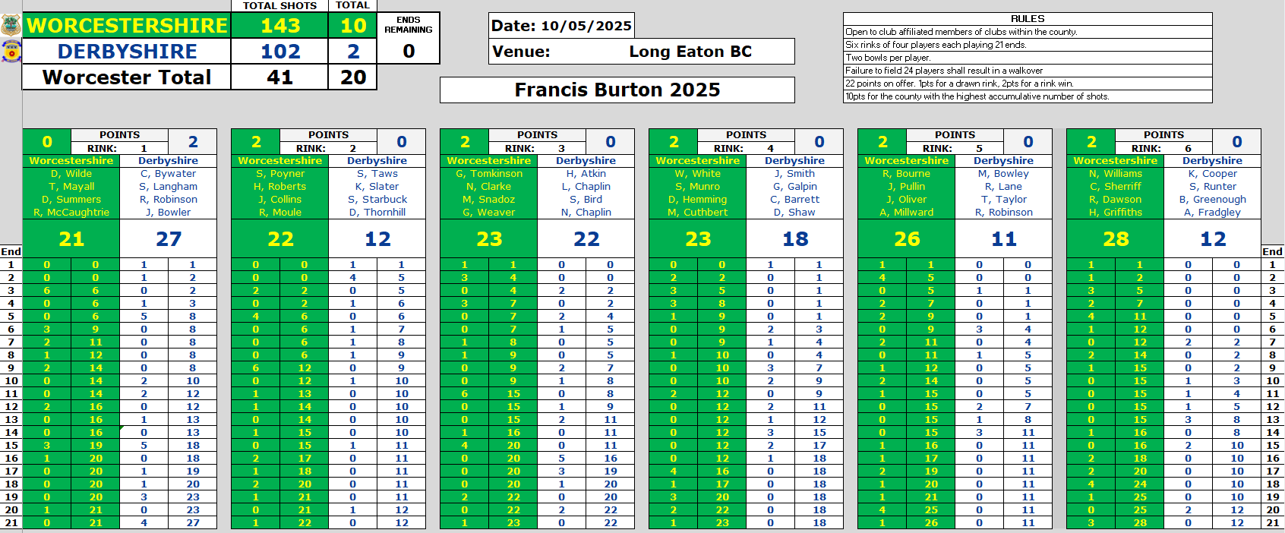
A great team performance and attitude all round on a sporting patch. Next up we have the Balcomb trophy event, team squad have been selected for this event and will release this tomorrow. Thanks to all the reserves and supporters, all who made the journey to Long Eaton. Also, thanks to Long Eaton bowls club for hosting the game. A big thank you to Kirsty Atkin the umpire on the day.

